1.Write a Java program that prints "VALID" only if a number:
is divisible by 3
NOT divisible by 5
lies between 50 and 200 (inclusive)
Otherwise print "INVALID"
➡️ Use only one if statement
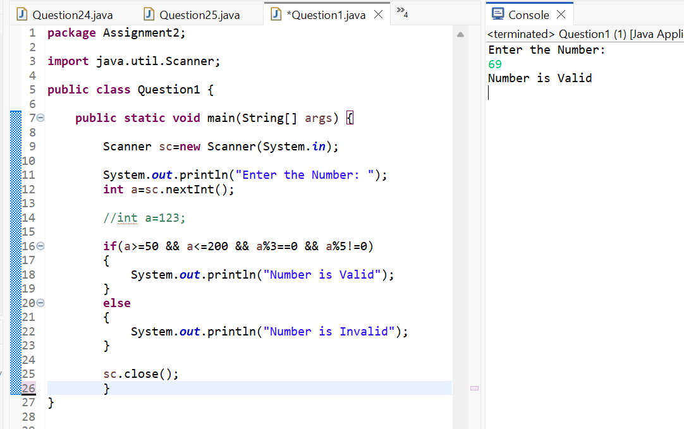

2.Given three integers a, b, and c, print the second largest number using:
Only if–else
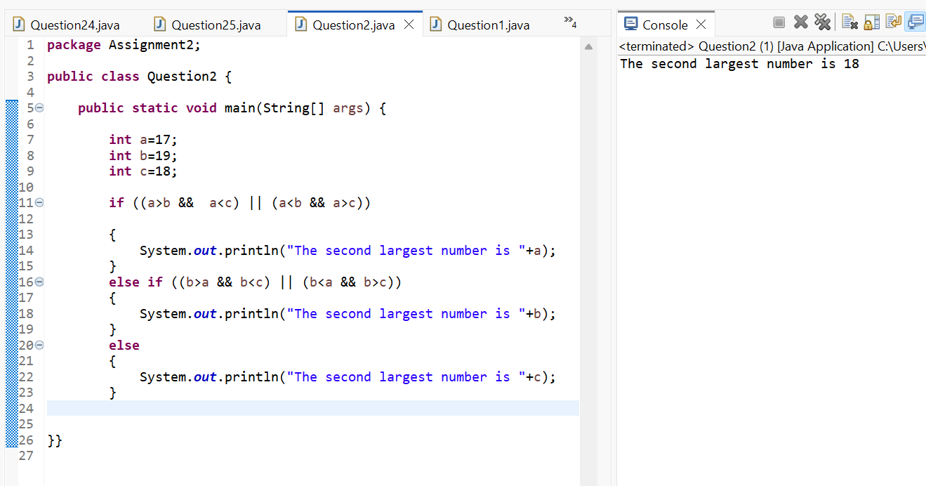

3.Write a program to check if a year is a leap year
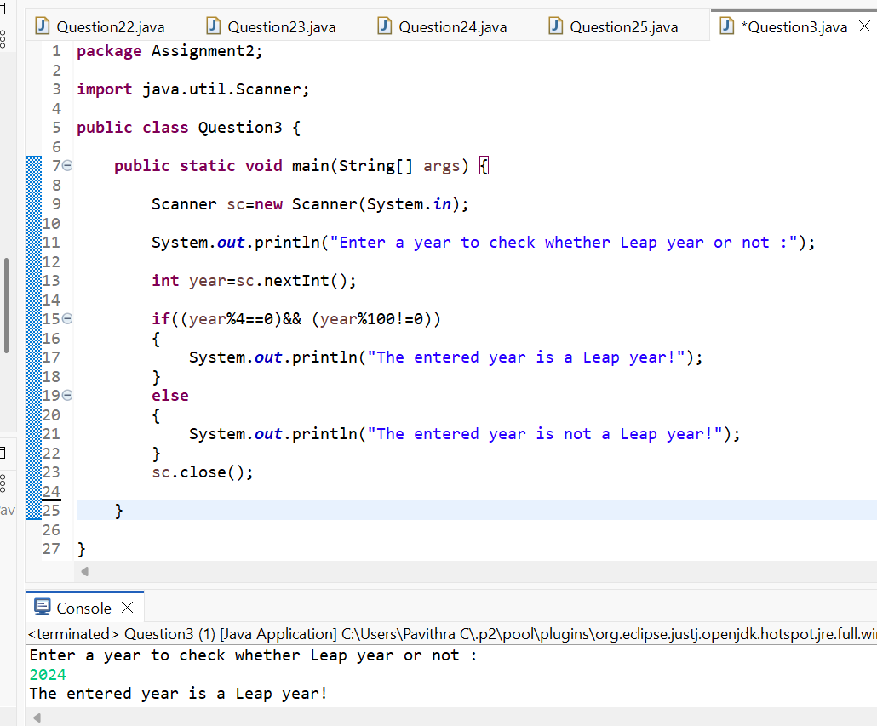

4.Input an integer and determine whether: It is positive and divisible by 4 OR negative and divisible by 6
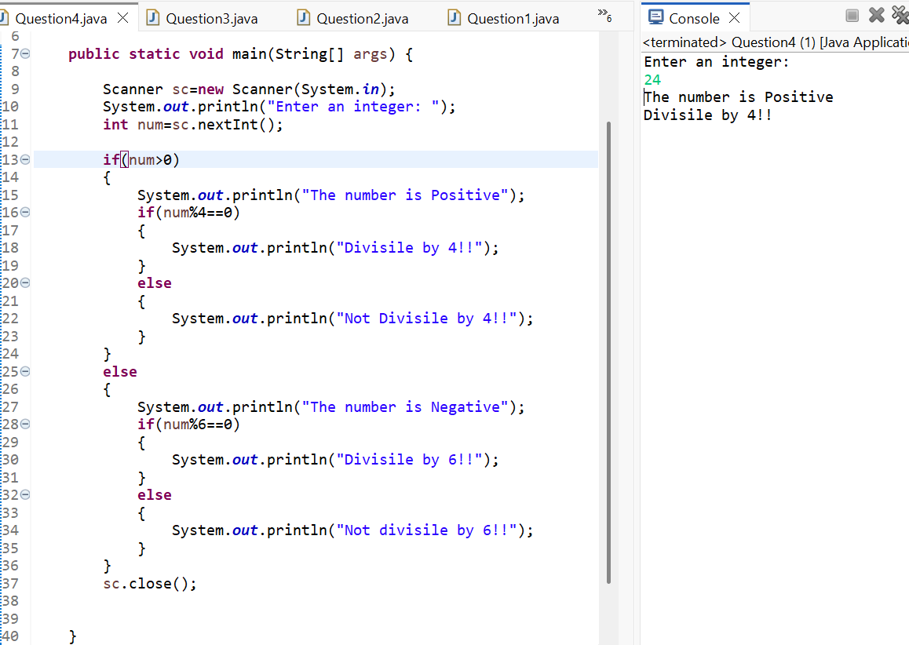
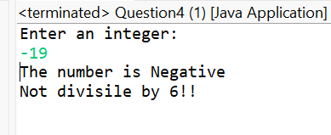
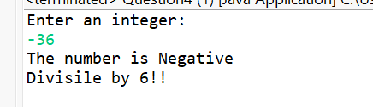

5. Write a program that prints:
"A" if number divisible by 2 and 3
"B" if divisible by 3 and not by 2
"C" if divisible by 2 and not by 3
"D" otherwise
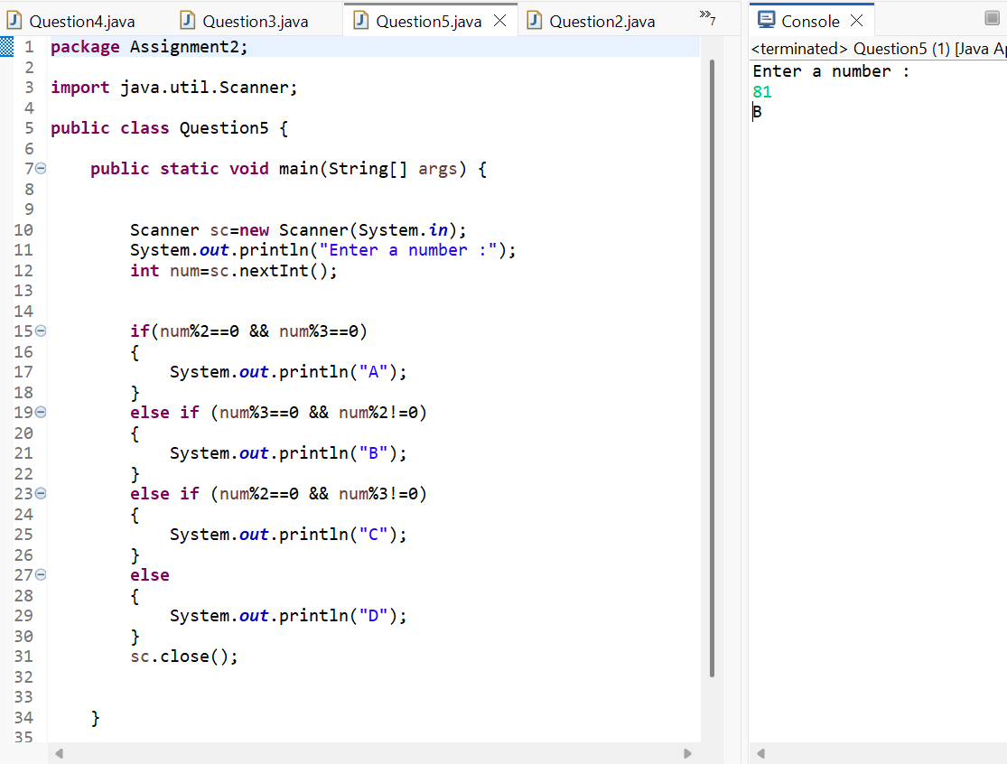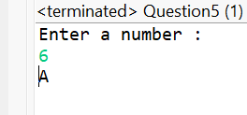
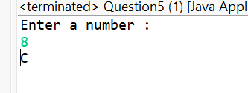
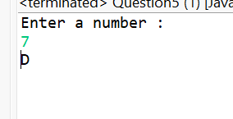

🔹 NESTED IF–ELSE (Complex Conditions)

6.Given marks in Math, Physics, Chemistry, determine eligibility:
Math ≥ 60
Physics ≥ 50
Chemistry ≥ 40
AND Total ≥ 180 OR Math + Physics ≥ 120
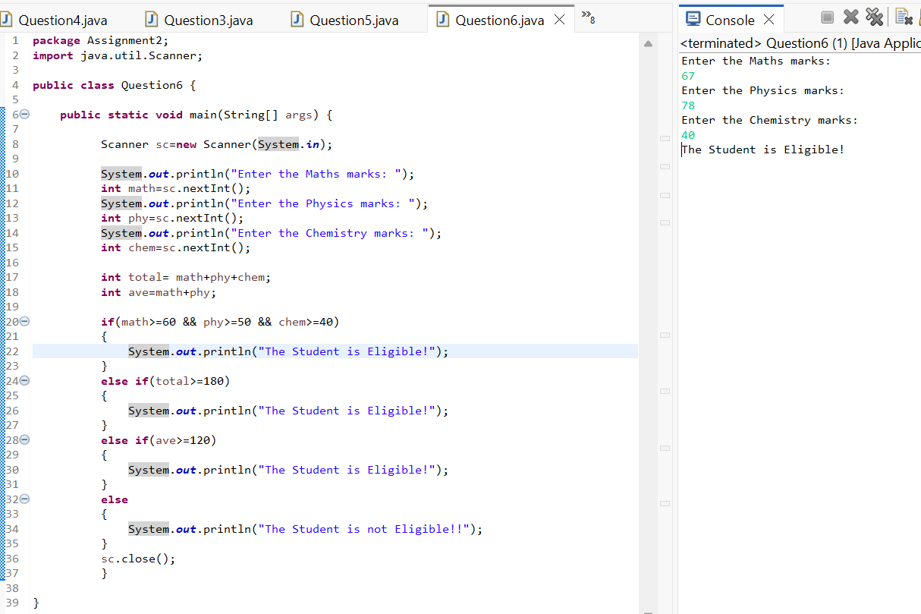
7.Write a program to find the largest of four numbers using:Nested if–else only,No loops,No arrays
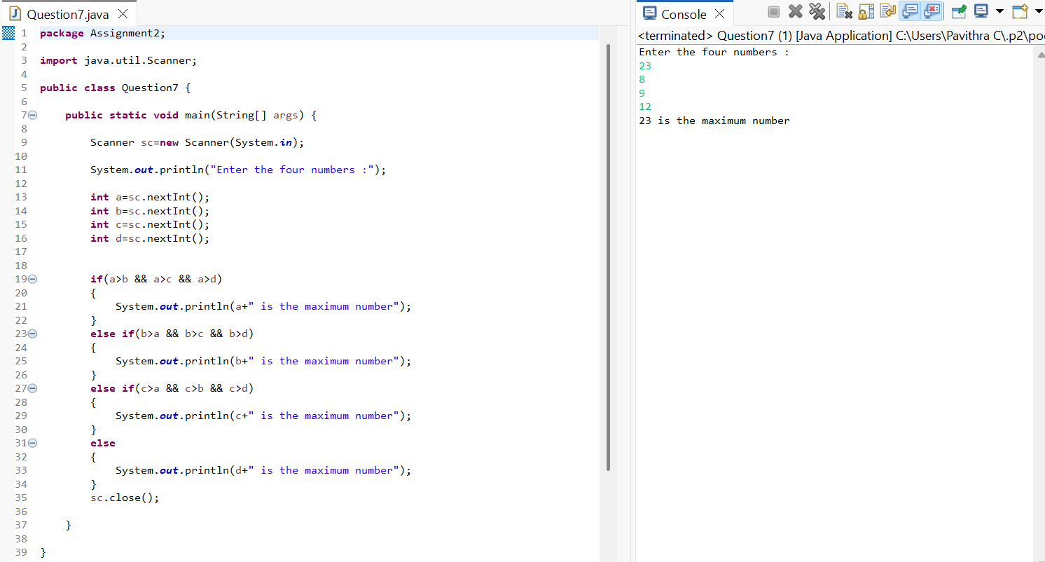

8.Given age and salary:
If age < 25 → Not eligible
If age ≥ 25 and salary < 30000 → Eligible for loan A--->>27 35000
If age ≥ 30 and salary ≥ 50000 → Eligible for loan B
➡️ Use deep nested if
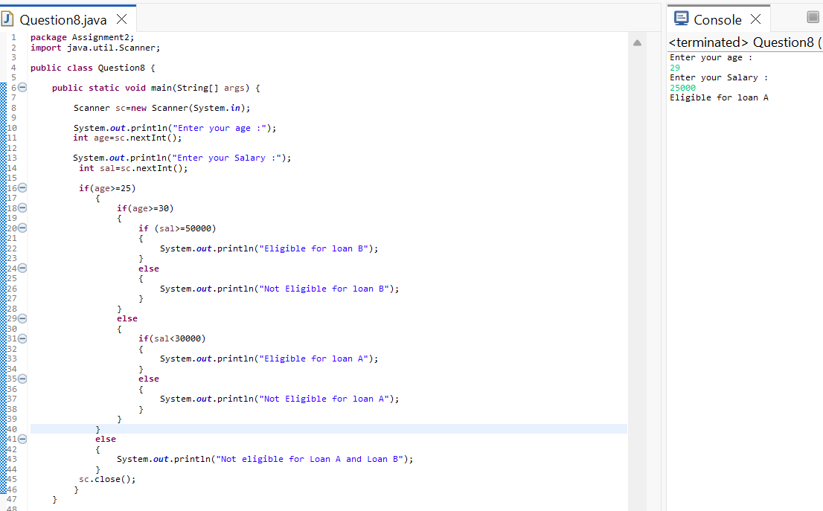

9.Write a program that classifies a character as:
Uppercase vowel A E I O U
Uppercase consonant
Lowercase vowel a e i o u
Lowercase consonant
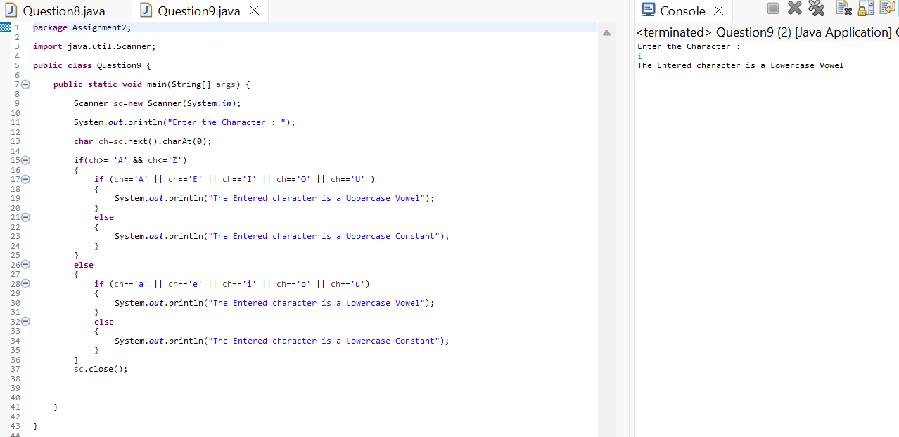
10.Input a number and check:
If it’s a 3-digit number
If yes, check whether the sum of digits is even or odd
➡️ Use nested if only
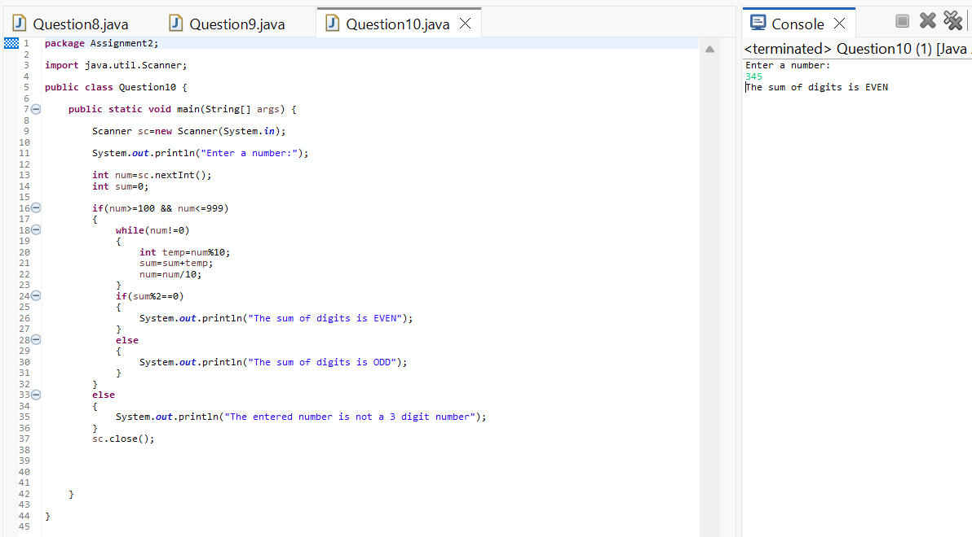

🔹 WHILE LOOP (Tricky Iterations)
11.Print numbers from 1 to 100 but:
Skip numbers divisible by both 3 and 5
Stop completely when number reaches 77
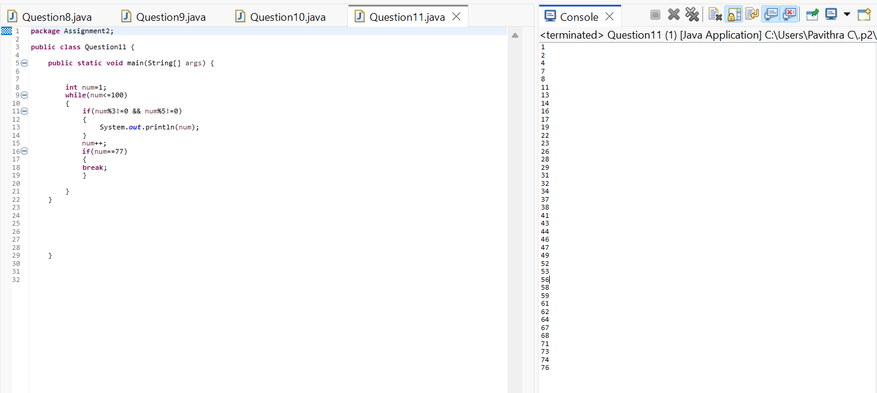

➡️ Use while only

12.Write a program to reverse a number using while, but:
Stop reversing if digit 0 is encountered
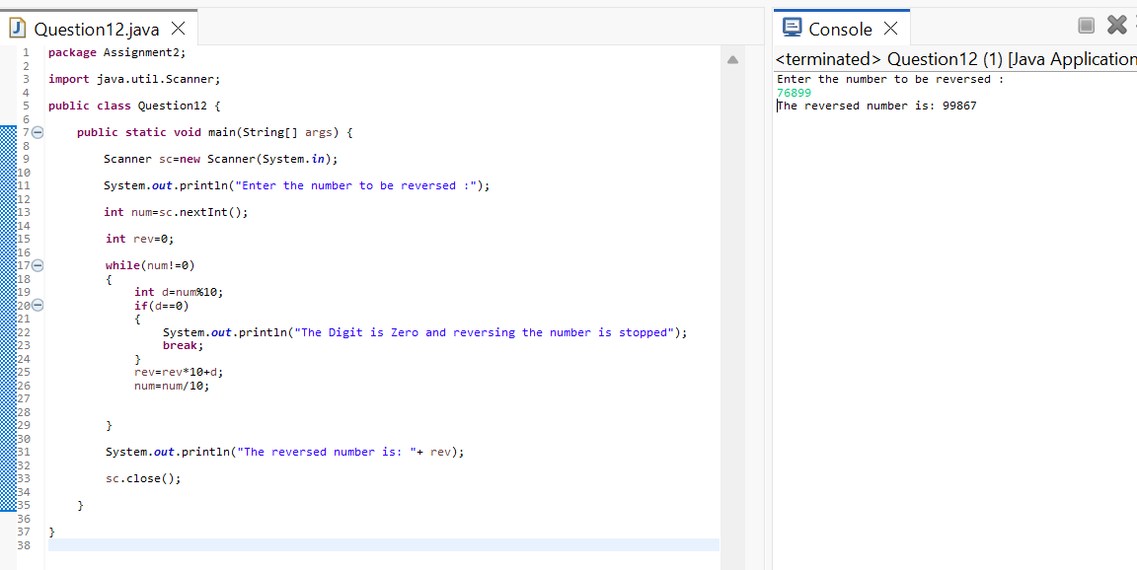

13.Find the count of prime digits in a number using while loop only
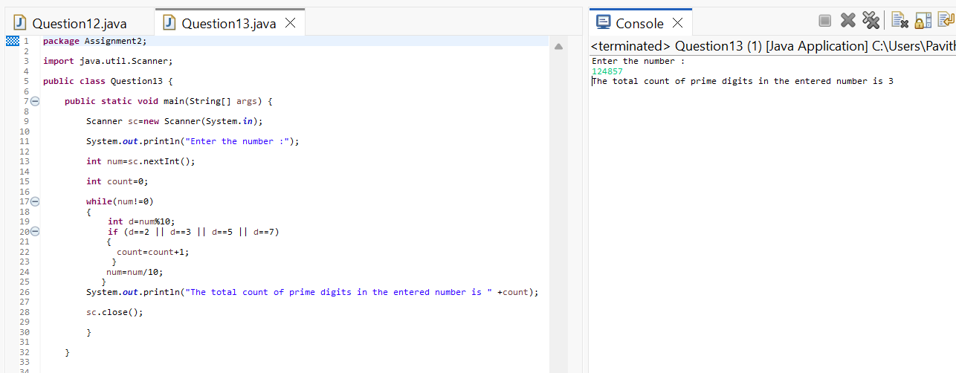

14.Write a program that prints the Fibonacci series up to N terms, but:
Stop printing when a number exceeds 500
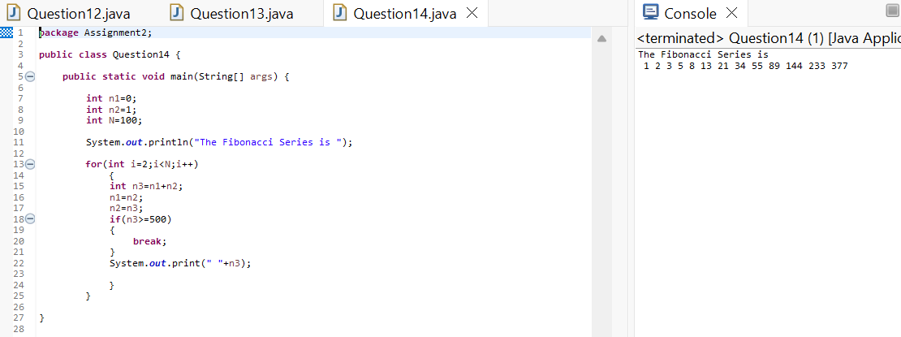

15.Using while, print the following sequence:1 2 4 7 11 16 22 ...(up to N terms)

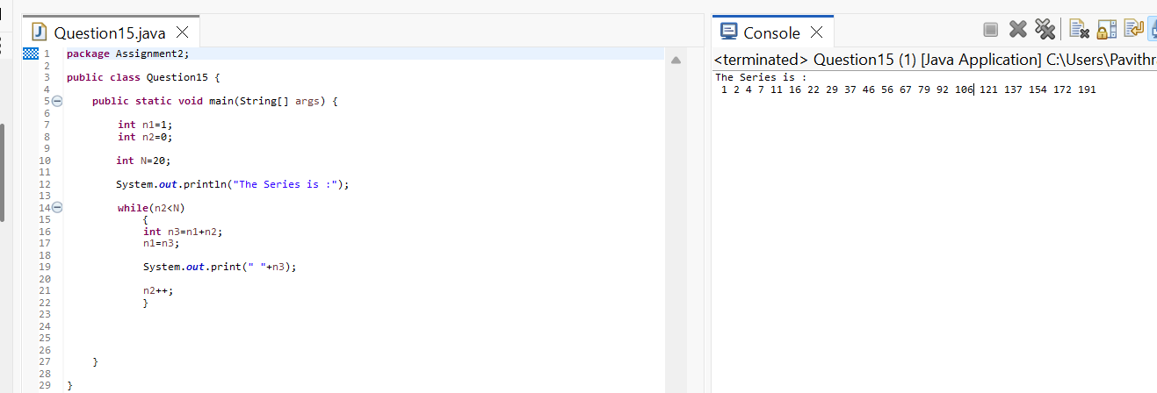

🔹 DO–WHILE LOOP (Edge Cases)
16.Write a program that:Takes user input until a negative number is entered
Prints sum of all even numbers entered
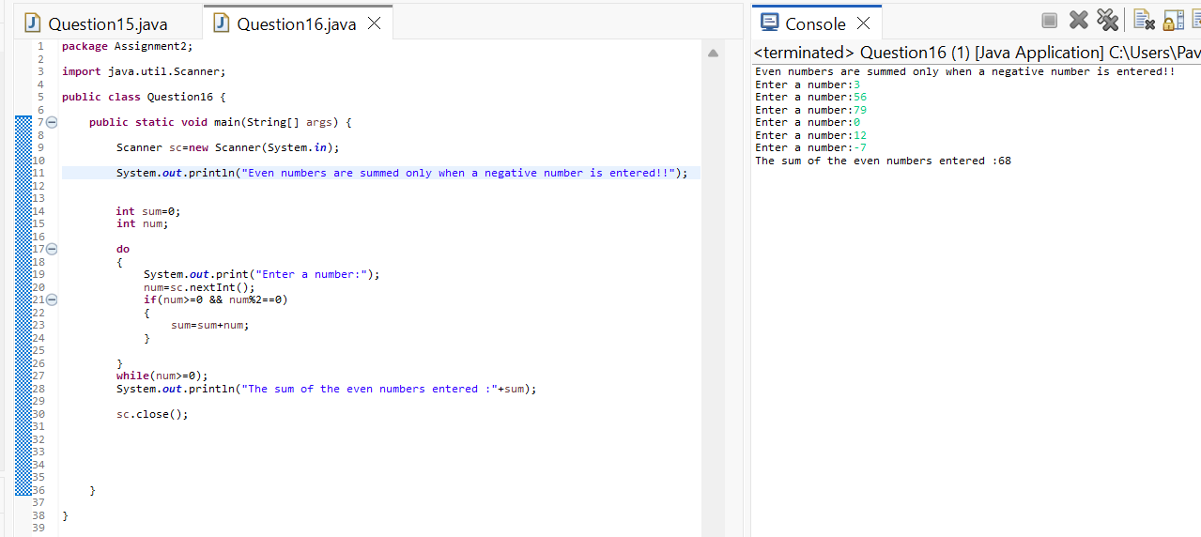
➡️ Use do–while
17.Using do–while, print digits of a number from left to right(No strings, no arrays)
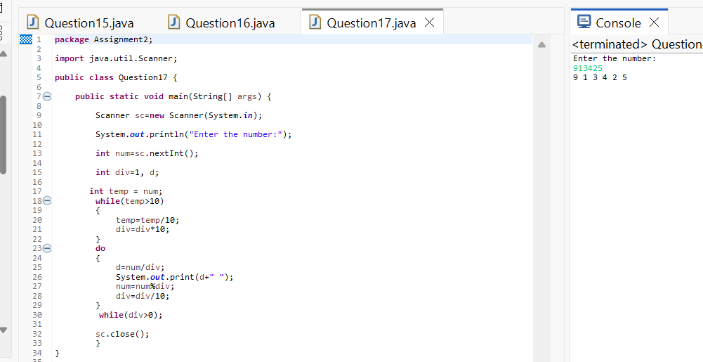

18.Write a program that executes at least once, even if condition is false, and prints:
Loop Executed
➡️ Modify condition logically
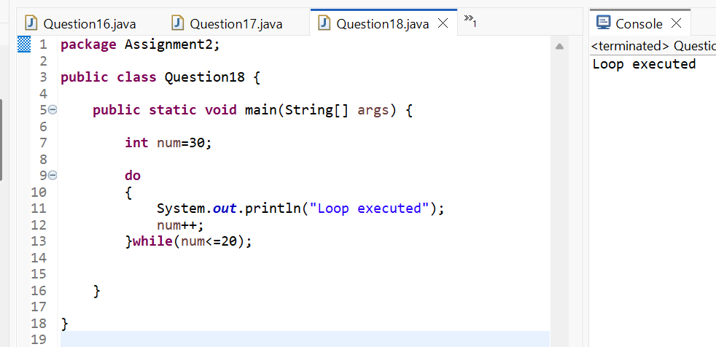

19.Create a menu-driven program using do–while:
Add
Subtract
Multiply
Exit
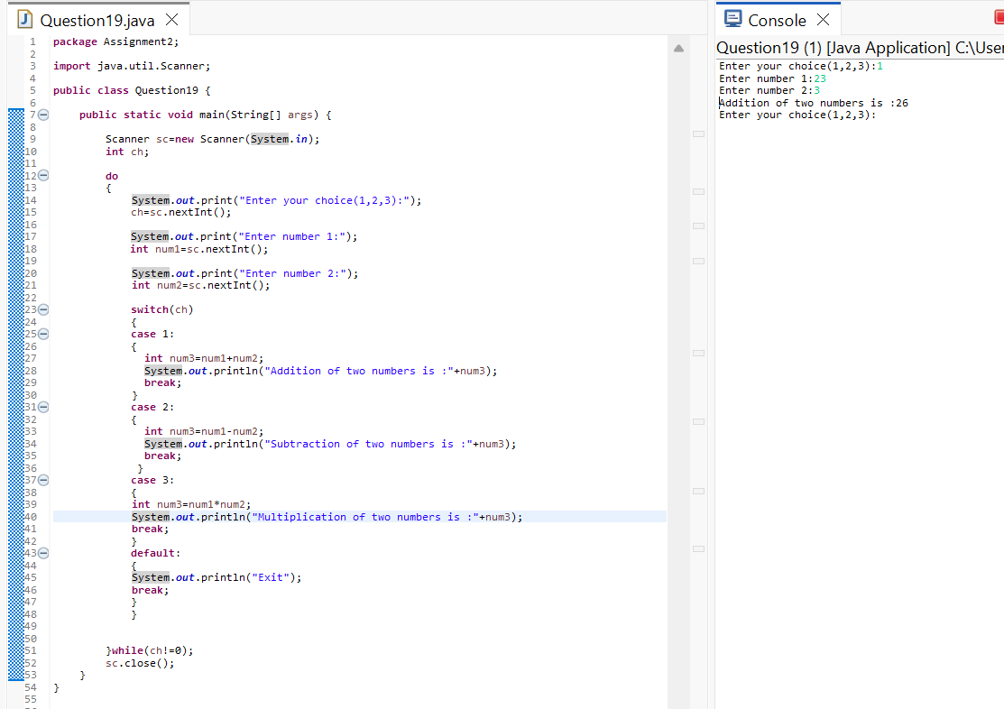

20.Using do–while, find whether a number is palindrome, but:
Exit loop early if mismatch is found
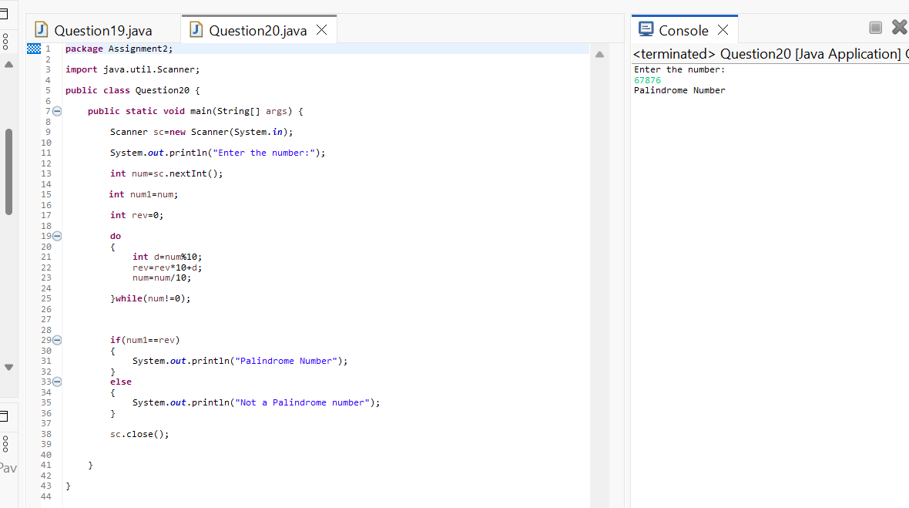
🔹 FOR LOOP (Advanced Logic)
21.Print all numbers between 1 and 500 that:Have exactly 3 divisors
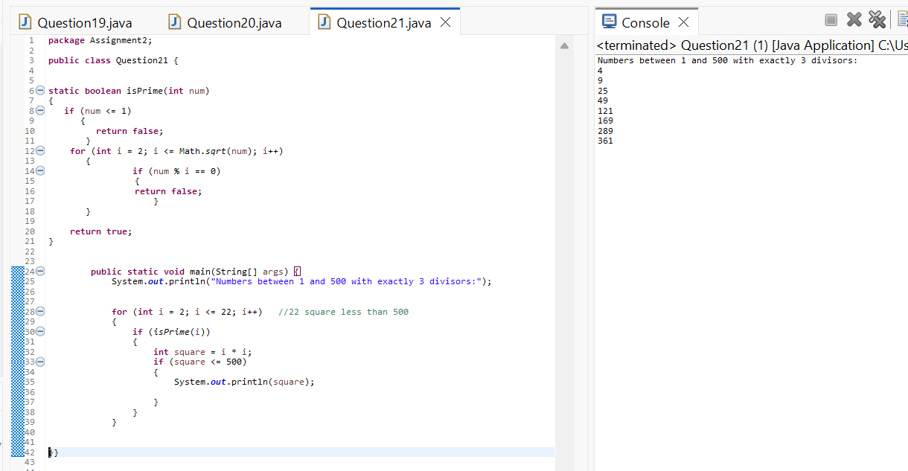

22.Using for, find the largest palindrome number between 100 and 1000
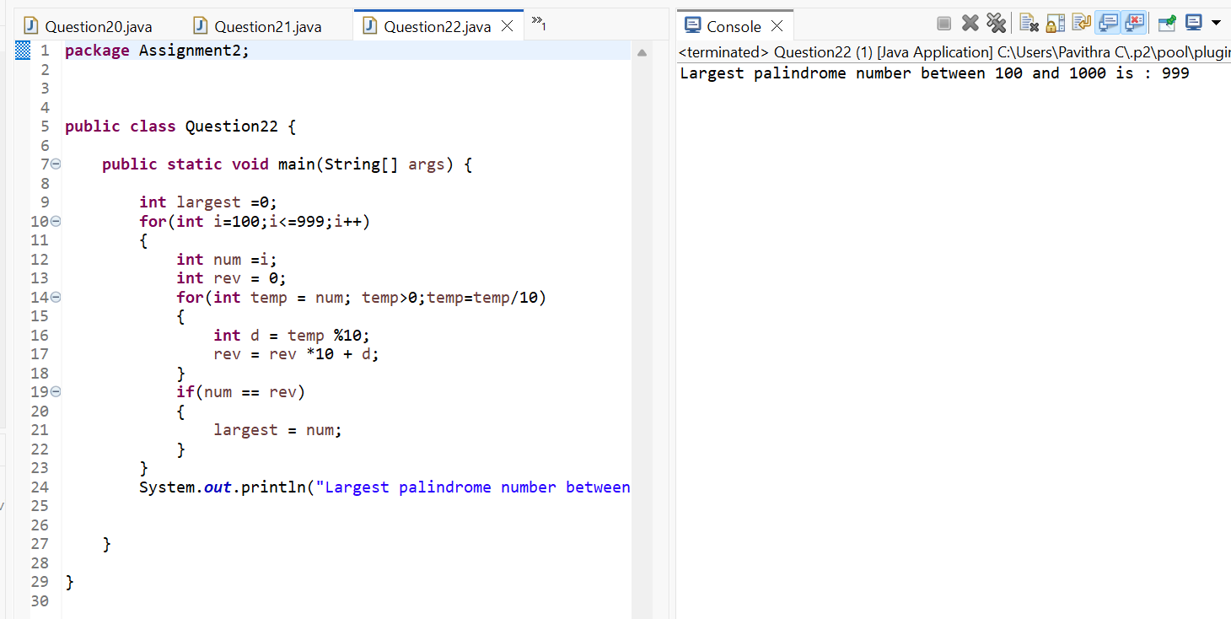

23.Print this pattern using nested for:
1
12
123
1234
12345
But skip printing 3 in all rows

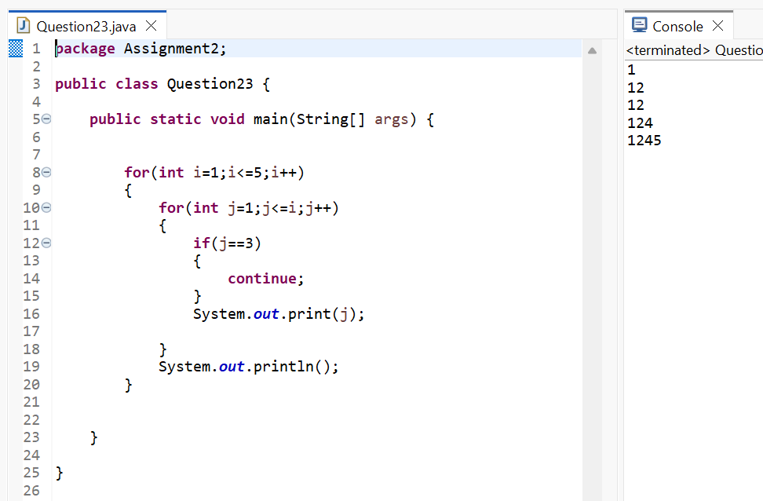
24.Using nested for, print:
5 4 3 2 1
4 3 2 1
3 2 1
2 1
1
But do NOT use subtraction operator (-)
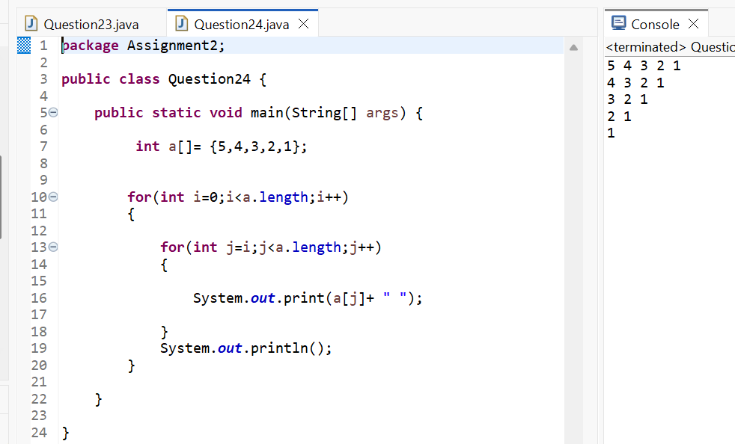

25.Write a program to print all perfect numbers between 1 and 10000 using:
Nested for if condition only
